Greco Feudal GDD

# Overview

## Summary

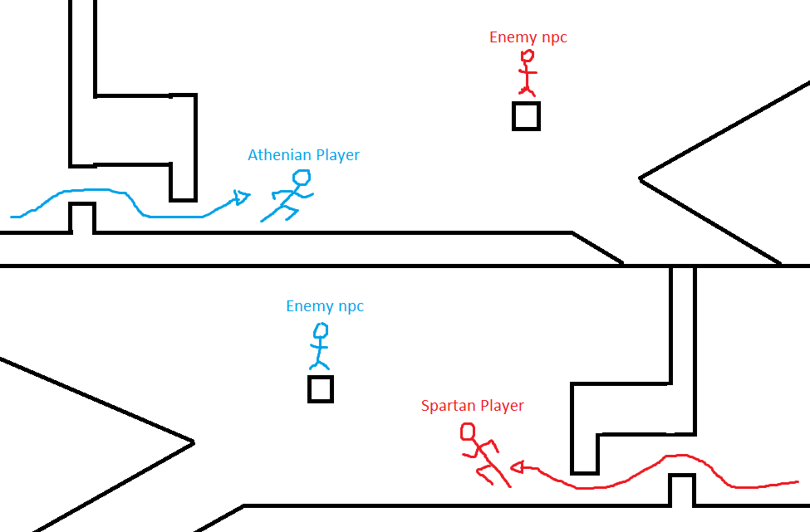2 players share a screen and run towards each other. They navigate a 2D symmetrical map, facing enemies and obstacles along the way until they meet in the middle and have a climactic battle to decide a war.

## Pillars

1. Unique Culture Blend
2. Player vs Player
3. Rapid Gameplay

## Story

Athens broke the treaty between them and Sparta, and thus the Peloponnesian war started. Due to their differing strengths the war has been at a stalemate for quite some time, so something has to change. The leaders of each nation, Pericles and Archidamos have agreed to send in their greatest warriors (the players) to duel for the fate of the war.

## Moral Argument

Political negotiations and all-out war cause misery, suffering, and are never ending. The only good way to solve a dispute is one on one combat between individuals that embody the nations.

This will be shown through:

1. Negotiations and war failing to achieve peace (cutscene)
2. A one on one battle commences (gameplay)
3. The bloodshed ends and peace falls over the land (cutscene when someone wins)

Each side has their reasons to fight:

* Athens
  + Sparta initiated combat first and we are just defending ourselves.
  + Sparta is the reason diplomacy failed and continued the bloodshed.
* Sparta
  + Athens broke the Thirty Year Treaty and thus forced our hand to war.
  + Athens has been using underhanded tactics to gain the advantage dishonourably.

## Aesthetic

Ancient times with a mix of Japanese and Greek culture. Inspiration from kung fu movies with the over-the-top action scenes and fast-paced editing.

## Unique Selling Point

* A blend of cultures that hasn’t been explored before. A mix of Greek and Japanese culture that creates a new and interesting aesthetic.
* 2 players facing off in a rapid approach and duel that tests skills like coordination, judgement, and reaction time.
* Symmetrical gameplay on a single screen and keyboard.

## Target Market

This game is targeted towards people that:

* Like ancient history
* Enjoy fast paced games
* Want competitive aspects in games
* Don’t have a lot of free time

# Art Direction

## Platform Design

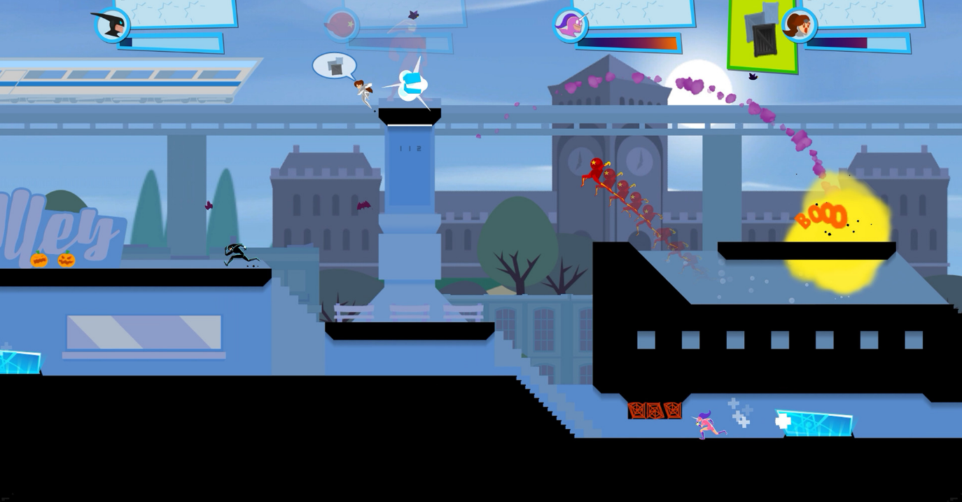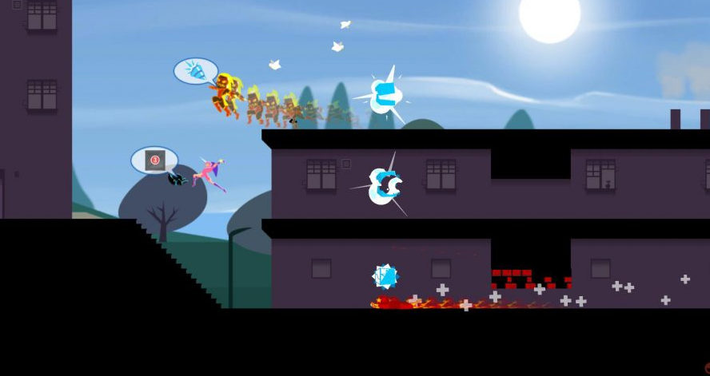

Floating platforms that are supported by background elements.

Different paths that the player can choose.

## Art Style

Background plates that add depth. Less detailed than foreground

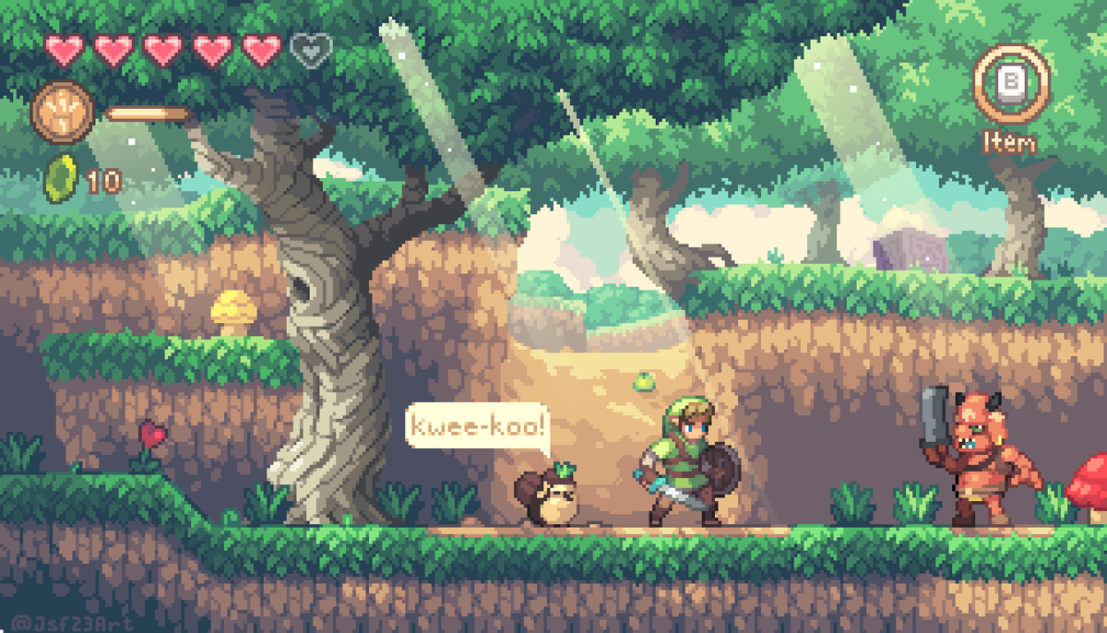

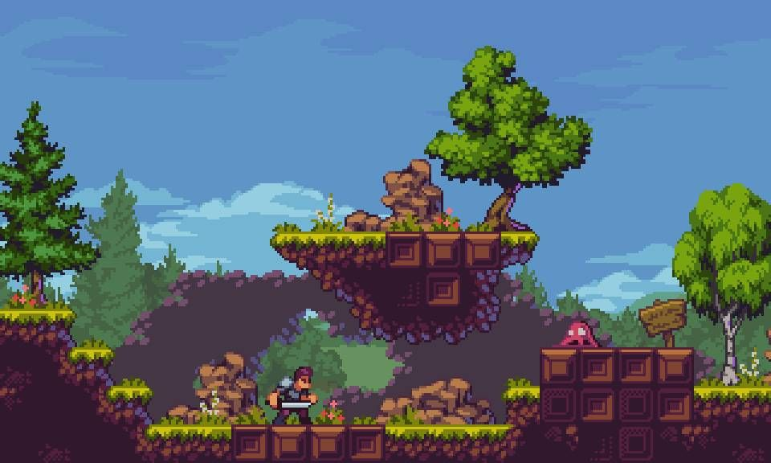

Pixelated general shape and low detail

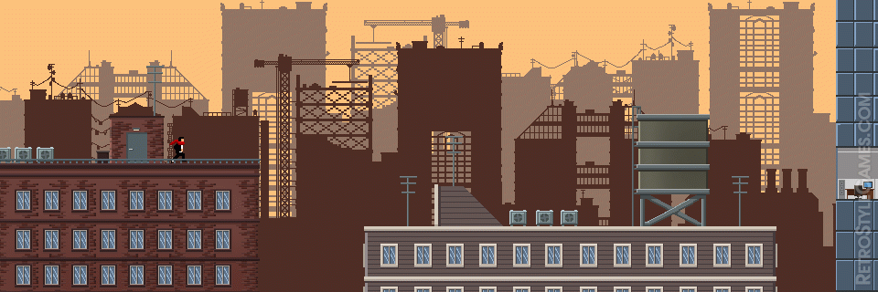

Not too detailed environment. Just enough to tell what it is.

## Content

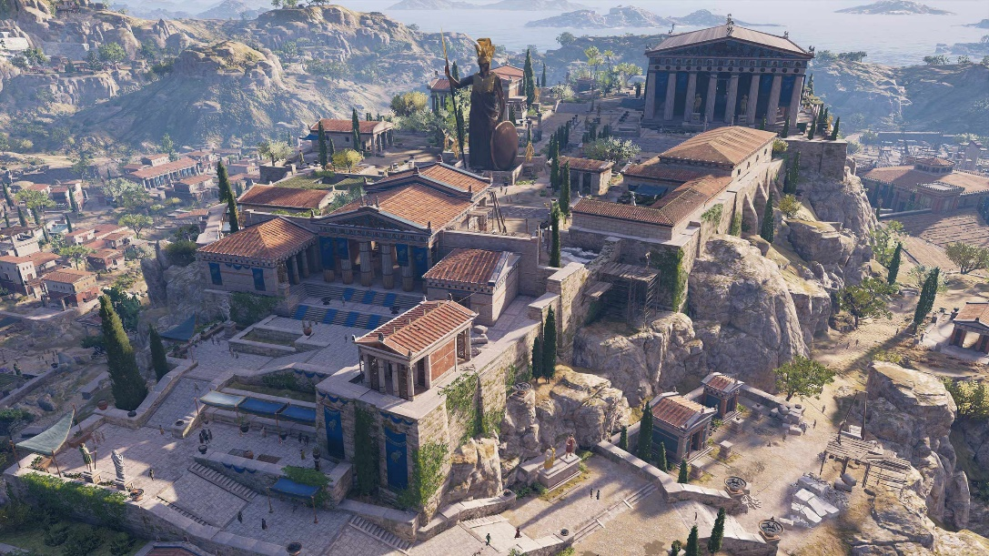

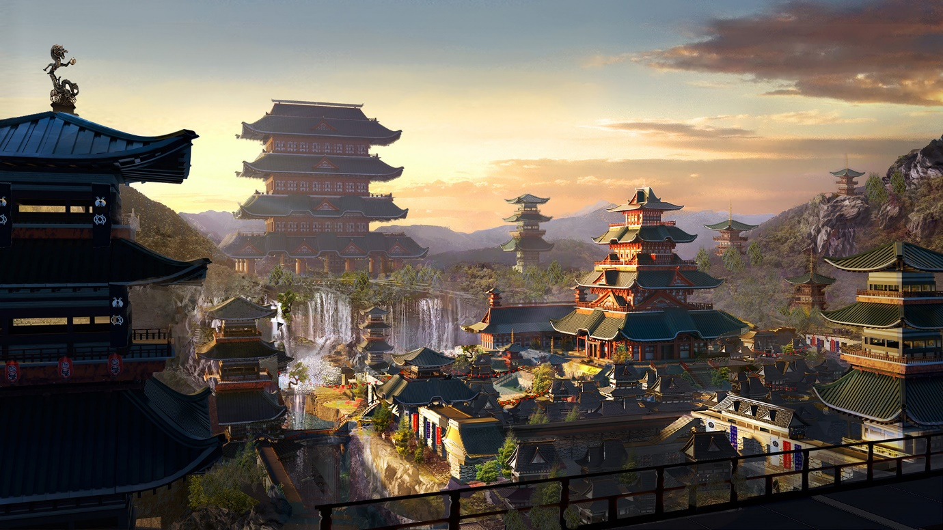

Combination of Greek and Japanese architecture

# Gameplay

## Description

Each player uses half of one screen (top and bottom) and automatically runs towards the other.

The map is branching and allows for different pathways that all eventually lead to the middle where the final battle will happen.

Along the way of these paths there will be obstacles such as walls to slide under and crates to jump over.

There are also enemies in the path that can be killed for special items that increase your abilities for the final battle.

When the players meet they must face off in a quick time event competition that simulates the quick strikes they are giving, until one of them loses all their health.

## Loops

# Mechanics

## Run

Player automatically runs forward at an unchanging speed which is uninterruptable. (If they hit a wall or enemy they just lose health instead of coming to a stop.)

## Jump

Player can jump to avoid obstacles/enemies and change their path. Any flat vertical surfaces will be broken through (like a wood wall) and they won’t be able to get stuck on corners.

## Slide

Player can slide underneath obstacles like small gaps.

## Dagger Throw

Player can attack mid jump to throw a dagger at the nearest enemy. It aims directly at them with no player input required.

## Slice

Player can slash forward and kill an enemy in one hit.

## Duel Showdown

Quick time event requiring the players to face off with accurate button presses.

# Controls

## Computer Gamer Keyboard Wasd Keys Vector Illustration Wasd Keys Game Control Keyboard Buttons Stock Illustration - Download Image Now - iStockPlayer 1

Jump – W

Slide – S

Slice – D

Dagger – A

## Player 2

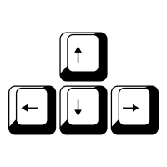Jump – Up Arrow

Slide – Down Arrow

Slice – Left Arrow

Dagger – Right Arrow